Software Requirements Document
Intelligent Work Management

Presented to:

Sonalysts

May 4, 2011

Nadia Boumaza, Chris Duffy, Kenneth M. Levine, Michael Peter
407-299-3900
MasterLink Corporation
3649 All American Boulevard
Orlando, Florida 32810


Revision History
Version Number | Date | Description | Author
0.01 | 4/26/2011 | Initial Draft | Michael Peter
Configuration of this Document
This document is under full configuration management.

Table of Contents

1. Introduction 5
1.1 Purpose 5
1.2 Scope 5
1.3 Definitions, Acronyms, and Abbreviations. 6
1.4 References 7
1.5 Overview 8
2. The Overall Description 10
2.1 Product Perspective 10
2.1.1 System Interfaces 10
2.1.2 Interfaces 11
2.1.3 Hardware Interfaces 11
2.1.4 Software Interfaces 11
2.1.5 Communications Interfaces 11
2.1.6 Memory Constraints 12
2.1.7 Operations 12
2.1.8 Site Adaptation Requirements 13
2.2 Product Functions 13
2.3 User Characteristics 14
2.4 Constraints 14
2.5 Assumptions and Dependencies 15
2.6 Apportioning of Requirements. 15
3. Specific Requirements 16
3.1 External Interfaces 16
3.2 Functions 18
3.2.1 Automated Scheduling Services 18
3.2.2 Maintenance Work Management 19
3.2.3 Maintenance Data Management 22
3.3 Performance Requirements 23
3.4 Logical Database Requirements 24
3.5 Design Constraints 24
3.5.1 Standards Compliance 25
3.6 Software System Attributes 25
3.6.1 Availability 25
3.6.2 Extensibility 26
3.6.3 Interoperability 26
3.6.4 Maintainability 26
3.6.5 Portability 26
3.6.6 Reliability 26
3.6.7 Security 27
4. Change Management Process 28
5. Document Approvals 30

1. Introduction

1.1 Purpose

The purpose of this document is to capture and enumerate the business and system/functional requirements for the TO12 Intelligent Work Management (IWM) system. The audience for this document is NSW Dahlgren Division W62 representatives for TO12, the Sonalysts project team, and the MasterLink (MLC) project team.

This document was originally intended for Marine Corps Motor Transport Maintenance requirements holders to review and sign-off on. However, due to circumstances beyond Sonalysts/MLC project management control, the IWM project does not have Marine Corps Motor Transport Maintenance contacts to generate these requirements or to sign-off on them. Instead, an internal Sonalysts subject matter expert was used for consultation and additionally provided access to Marine Corp technical documentation. Both the consultation and the technical documentation listed in section 1.4, References, were used to generate this document.

In the future, if the IWM system will be utilized by Marine Corp Motor Transport Maintenance shops, this document should be reviewed and signed off by appropriate Marine Corp Motor Transport Maintenance requirements holders. Since the input of these individuals was not available in the timeframe required to complete this document, it is anticipated that some changes, whether significant or otherwise will be required to the document and to the software product. As such, this document and the IWM software will be considered iterative versions until the close of TO12 on September 23, 2011.

Although the requirements are being delivered on May 16, 2011 as scheduled, the team will iterate on the requirements, including user interface design, for as long as is practical within the timeframe of TO12, and within the constraints of budget and time. Should any new critical information become available to the team that has not currently been available, the team will either incorporate it in the current project, or defer it to a future phase of the project.

1.2 Scope

The TO12 Intelligent Work Management system is designed to run on any standard computer (laptop/server) in order to allow Marine Corps Motor Transport Maintenance Managers to update preventive maintenance events, create/update corrective maintenance events, search for specific maintenance events, view automatically generated schedules, and override schedule assignments.

Objective | Stakeholders | Success Criteria | Measurement
Successful delivery of IWM demonstration system | All | Completion of demonstrable system scenarios | Development and test complete by September 1, 2011.
Automated planning of preventative maintenance | Marine Corps Motor Transport Maintenance Managers | Automated creation of preventative maintenance work | Preventative maintenance jobs created according to specified intervals for 100% of the vehicles in the system.
Automated scheduling of preventive and corrective maintenance | Marine Corps Motor Transport Maintenance Managers | Automated assignment of preventative maintenance to workers/resources | 100% of maintenance jobs for which resources exist automatically assigned to required resources. The user will have the capability to manually override 100% of the automated assignments.
Automated tracking of preventative and corrective maintenance | Marine Corps Motor Transport Maintenance Managers | Current status and activity available for preventative and corrective maintenance | Data in the system reflects the current status and work-to-date for each job.

Out of Scope
The following work is outside of the scope of this project:

- Classroom or training-based scheduling
- Training, operations and maintenance at the Marine Corps Motor Transport maintenance facility

1.3 Definitions, Acronyms, and Abbreviations.

Term | Definition
ANSI SQL | American National Standards Institute Structured Query Language, which describes canonical database query functions
CM | Corrective maintenance
ERO | Equipment Repair Order
GCSS | Global Combat Support System. The system being deployed to replace MIMMS/SASSY,
HTTPS | HyperText Transfer Protocol Secure
IWM | Intelligent Work Management – the system being developed
Marine Corps Motor Transport Maintenance Managers | Maintenance management officers and/or maintenance chiefs in charge of assigning, managing, and reviewing maintenance work.
MIMMS | Marine Corps Integrated Maintenance Management System. The system currently used to record data resulting from maintenance activity.
PMCS | Preventive maintenance checks and services
SASSY | Supported Activities Supply System. The system currently used to manage parts and inventory.
Software Requirements Specification/Document | A document that completely describes all of the functions of a proposed system and the constraints under which it must operate. This document is an example.
Stakeholder | Any person with an interest in the project who is not a developer.
TCP/IP | Transmission Control Protocol/Internet Protocol. The communication protocol used to transmit information on local and wide area networks, including the Internet
User | Marine Corps Motor Transport Maintenace Manager

1.4 References

IEEE. IEEE Std 830-1998 IEEE Recommended Practice for Software Requirements Specifications. IEEE Computer Society, 1998.

USMC. MCO P4790.2C W CH 1: MIMMS Field Procedures Manual. United States Marine Corps, 1994.

USMC. MTMOC 2208: Student Outline MIMMS AIS Reporting Procedures. United States Marine Corps.

USMC. NAVMC 10561: Preventive Maintenance Checks and Services Roster. United States Marine Corps, 1995.

USMC. NAVMC 3500.39: Motor Transport Training and Readiness Manual. United States Marine Corps, 2008.

USMC. TM 9-2355-108-10: Operator Manual Commercial off-the-shelf (COTS) for RG33 and RG33L Mine Resistant Vehicles. United States Marine Corps

USMC. TM 4700-15/1H: Ground Equipment Record Procedures. United States Marine Corps

USMC. TM 9-2355-335-23 Maintenance Manual Commercial-off-the-shelf (COTS) for Mine Resistant Ambush Protected All Terrain Vehicle (M-ATV). United States Marine Corps, 2009.

USMC. UM-4400-124: FMF SASSY Unit Using Procedures, Marine Corps Users Manual. United States Marine Corps, 1984.

USMC. UM-4790-5: MIMMS Field Maintenance Procedures, Marine Corps Users Manual. United States Marine Corps. 1983.
USMC. Marine Corps Motor Transport Maintenance Officer training syllabus and course material. United States Marine Corps.

USMC. II MEF Organizational chart. United States Marine Corps.

USMC. Marine Corps Bulletin 3000. United States Marine Corps.

USMC. Standard Operating Procedures (SOP) for the Marine Corps Integrated MaintenanceManagement System (MIMMS) in 2D Marine Aircraft Wing. United States Marine Corps.

USMC. Maintenance Manual Commercial off-the-shelf (COTS) for RG33 and RG33L Mine Resistant Vehicles. United States Marine Corps.

USMC. Repair Parts and Special Tools (RPSTL) Manual Commercial off-the-shelf (COTS) for RG33 and RG33L Mine Resistant Vehicles. United States Marine Corps.

USMC. Operator’s Manual for 6X6 Joint EOD Rapid Response Vehicle (JERRV). United States Marine Corps.

USMC. Maintenance Manual for 6X6 Joint EOD Rapid Response Vehicle (JERRV). United States Marine Corps.

USMC. Parts Manual for 6X6 Joint EOD Rapid Response Vehicle (JERRV). United States Marine Corps.

USMC. JERRV Maintenance Manual Appendix B Electrical Schematics. United States Marine Corps.

USMC. Operator Manual Commercial-off-the-shelf (COTS) for Mine Resistant Ambush Protected All Terrain Vehicle (M-ATV). United States Marine Corps.

USMC. Repair Parts and Special Tools List Commercial-off-the-shelf (COTS) for Mine Resistant Ambush Protected All Terrain Vehicle (M-ATV). United States Marine Corps.

USMC. MTVR IETM. United States Marine Corps.

1.5 Overview

This specification is organized into the following sections:
- Introduction, which introduces the specification for the TO12 IWM system to its readers.
- Overall Description, which provides a brief, high level description of the TO12 IWM system including its definition, business goals, business objectives, context, and capabilities.
- System Requirements, which includes the following sections:
- External Interfaces, specifies the external interfaces supported.
- Functional Requirements, specifies the functional system requirements in terms of system requirement statements.
- Performance Requirements, which specifies the required system performance factors.
- Logical Database Requirements, which specifies the system data requirements in terms of required data components.
- Design Constraints, which documents required architecture, design, and implementation constraints.
- Software System Attributes, which defines the system non-functional requirements.

2. The Overall Description

2.1 Product Perspective

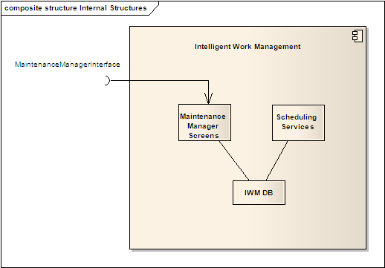

The Intelligent Work Management system has one primary actor who has access to the web-based maintenance management screens: The Marine Motor Transport Maintenance Manager. This user views/updates the current maintenance work and maintenance assignments through the maintenance management screens.

The Scheduling Services handle the automated creation, assignment, and tracking of maintenance work, storing information in the IWM database for retrieval through the maintenance management screens.

2.1.1 System Interfaces

Interface | Functionality | Description
Maintenance Manager Interface | Display/update preventive and corrective maintenance, display maintenance work assignments, override automated assignments | The Maintenance Manager Interface is composed of browser screens which exposes maintenance functionality to the user

2.1.2 Interfaces

Maintenance Manager Interface characteristics:
- Format: HTML/Cascading Style Sheets (CSS)
- Communication: Hypertext Transfer Protocol Secure (HTTPS)
- Client-side coding: Javascript

2.1.3 Hardware Interfaces

The IWM system can interact, either directly or indirectly, with any of the following significant external hardware:
- Client Hardware:
- Maintenance Shop Workstations, which are the personal computers used in the maintenance shop by personnel to view and record maintenance work.
- Maintenance Laptops, which are the portable computers used in outside-the-shop locations, including in-theater, to view and record maintenance work.
- Maintenance handhelds or tablets, which are mobile devices used
inside or outside the maintenance shop to view and record maintenance
work.
- Networks:
- Internet, which is the global network used for communication among maintenance personnel, users, and the IWM system.
- NMCI, the Navy/Marine Corps Intranet, which is the specialized network used by the US Navy and Marine Corps.
- Local Area Network, which is internal local area network used for communication among maintenance personnel and the IWM system.

2.1.4 Software Interfaces

The IWM system interacts, either directly or indirectly, with the following significant client software:
- Browser, which is the software tool that runs on maintenance personnel workstations and laptops that allows them to communicate either over the network with the IWM system, or with a local installation of IWM on the particular workstation/laptop.

2.1.5 Communications Interfaces

The IWM system uses TCP/IP (Transmission Control Protocol / Internet Protocol) and HTTPS (Hypertext Transfer Protocol Secure) to communicate with local and remote browsers.
The IWM system can be configured to use any TCP communication port. By default the IWM system communicates on TCP port 443.
The IWM system's database communicates with client applications via ANSI SQL (American National Standards Institute Structured Query Language). The IWM system's database is accessible from the local machine via TCP port 3306.

2.1.6 Memory Constraints

The IWM system operates within two gigabytes of primary memory and five
gigabytes of disk storage.

2.1.7 Operations

There can be two modes of user operation:
- Administrative mode: In this mode, administrative users with proper authorization can add, update, and delete IWM system users, e.g. maintenance managers.
- Maintenance management mode: In this mode, users are able to perform basic searches, view work schedules, detailed work information, maintenance technician information, and override any automated assignments generated by the IWM system. This is the primary mode of operation.

The unattended operation of the system is specific to the automated scheduling and assignment of work: The IWM system runs the scheduling services periodically at a user-configurable interval. These services create preventive maintenance events, and assign and track both preventive and corrective maintenance events against the maintenance personnel, e.g. maintenance technicians, who are available to perform the work.

Data processing carried out by the IWM system includes the following:
- Assigning maintenance work to maintenance technicians
- Tracking the creation, assignment, and completion of preventive and corrective maintenance
- Calculation of statistics and generation of reports
- Supporting flexible search across all data maintained by the IWM system

Data backups are performed at user configurable intervals: daily/weekly. System recovery is localized to the restoration of the IWM database from a data backup.

2.1.8 Site Adaptation Requirements

For each site proposed for installation, the following information must be captured and populated in the IWM system:

- Personnel information to generate accounts for the following types of users:
  - Administrative users: Users who will have authority to administer the existence and access of maintenance manager users
  - Maintenance managers: Users who will view maintenance work schedules, detailed work information, and maintenance technician information; override any automated assignments generated by the IWM system; and view reports on completed work and stored historical maintenance performance.
- Marine vehicle information: Standard Marine vehicle types are predefined in the IWM system.The user will select from the list of standard vehicles the type of vehicle against which maintenance work is to be performed and enter the serial number and other vehicle-specific data.

Once a user organization begins the engagement process with the development team, the best way to get this information into the system can be determined, including the following methods:
- Web services for information that exists in external systems that support web service communication
- Export, transform and load (ETL) for information in a database, which can be extracted and automatically loaded into IWM.
- An appropriate user interface for expert users to input paper-based data.

2.2 Product Functions

Automated Scheduling Services
- Create preventive maintenance checks and services (PMCS) at periodic intervals specified on each PMCS
- Assign PMCS and corrective maintenance (CM) to maintenance technicians, matching on skill/skill level, organization, priority, location, and resource availability.
- Track status of maintenance work

Maintenance Work Management
- View current and future maintenance work
- View current work assignments
- Update current and future maintenance work
- Override current maintenance work assignments
- View historical maintenance work performance

Maintenance Data Management
- Search for basic/advanced information: maintenance technician, vehicle, or maintenance work data
- View vehicle data, maintenance technician data, and maintenance work data.
- Update vehicle data, maintenance technician data, and maintenance work data

2.3 User Characteristics

The group of users of the IWM system consists of managers who interact with the system, and workers who are the recipients of work assignments. The hierarchy is described below:

Managers: Those users who will access the maintenance management screens in order to review/modify maintenance data and maintenance work assignments. This group may include:
- Maintenance Management Officer (MMO)
  - Commodity Manager
  - Maintenance Officer
    - Maintenance Chief
    - Shop Chief
- Supply Officer
- Commodity Officer
- Field Supply Maintenance Analysis Office (FSMAO) Officer in Charge (OIC)

Workers: Those users who are not managers, but may be authorized to interact with the system in order to enter data. This group may include:
- Records Clerk
- Technician (electronic, ordnance, etc.)
- Parts Person
- Inspector
- MIMMS AIS Data Entry Person

2.4 Constraints

Connectivity
The IWM system is intended to be deployable in any environment in order to support vehicle maintenance scheduling and assignment. Normal operation includes communication with external systems for ERO status updates and parts availability/status updates.

In-theater deployment may not support the connectivity required for external system communication. The IWM system has been designed to run in a connection-limited mode, allowing the user to step in and provide status updates so that automated scheduling and assignment can continue without interruption.

2.5 Assumptions and Dependencies

The IWM system provides support for external interfaces, however the following assumptions/dependencies must be fulfilled for each concrete external interface:

- An interface control document, specifying the data structures and types to be transmitted, transmission timing, and error handling must be defined between the IWM system and the external system. This involves procurement of time/resources for the owning organization of the external system.

- The communication infrastructure must be designed, showing the hardware and network systems that support the interface.

- Development and test of the interface must be performed for the IWM system as well as for the external system. This involves procurement of time/resources for the owning organization of the external system.

2.6 Apportioning of Requirements.

There is no apportioning of requirements for the IWM system.

3. Specific Requirements

3.1 External Interfaces

The external inputs/outputs into the IWM system are made via the Maintenance Manager Interface. The data is organized according to the following Marine Corps maintenance production concepts:

- ERO – An active maintenance work item; either preventive maintenance checks and services (PMCS) or corrective maintenance (CM). The ERO is the data item created and tracked in the IWM system,and against which resource assignments are made.
- Maintenance personnel – The personnel who assigned to peform the work required by the ERO.
- Non-asset resource/part – Parts required in the performance of vehicle maintenance
- Contact – The motor vehicle owning organization

ERO Attributes – PMCS/CM
Attribute | Name | Generated By | Default Value | Validation Rule
contact | Owner contact | Text field | Blank | Required
createdDate | Date ERO was created | System | Sysdate | Date. Required
daysInShop | Days in Shop (DIS) | System | Blank | Calculated
echelonOfMaintenance | Echelon of maintenance | Drop-down | Blank | Required
ero | ERO # | Text field | Blank | Alphanumeric. May be null
estimatedTime | Total estimated time | Text field | Blank | Integer. Required
Id | ID | System | Blank | Alphanumeric. Required
jobCategory | Category | Drop-down | Blank | Required
jobStatus | Status | Drop-down | Blank | Required
jobType | PMCS/CM | Drop-down | Blank | Required
model | Model | System | Blank | Required
Notes | Notes | Text box | Blank | Alphanumeric. May be null
ownerOrganization | Owner Organization | Drop-down | Blank | Required
priority | Priority | Drop-down | Blank | Required
qualifications | Qualifications | System | Blank | Required
receivedInShopDate | Date received in shop | Date entry | Sysdate | Date. Required
repairCompletedDate | Date closed | Date entry | Blank | Date. Required
serialNumber | Serial # | Text entry | Blank | Alphanumeric. Required
tam | TAM | System | Blank | Required

Maintenance Personnel Attributes
Attribute | Name | Generated By | Default Value | Validation Rule
active | Active | Drop-down | True | Boolean. Required
location | Location | Drop-down | Blank | Alphanumeric. Required
name | Name | Text field | Blank | Alphanumeric. Required
organization | Organization | Drop-down | Blank | Required
proficiency | Skill | Drop-down | Blank | Required
securityLevel | Security Level | Drop-down | Blank | Required
serialNumber | Serial Number | Text field | Blank | Alphanumeric. Required

Non-Asset Resource/Part Attributes
Attribute | Name | Generated By | Default Value | Validation Rule
canceledDate | Canceled Date | Date entry | Blank | Date. Required
itemNumber | Document Number | Text field | Blank | Alphanumeric. Required
name | Part-name | Text field | Blank | Alphanumeric. Required
narStatus | Status | Drop-down | Blank | Required
narStatusDate | Status Date | Date entry | Sysdate | Date. Required
narStatusHistory | Status History | System | Blank | May be null
nsn | Part-NSN | Drop-down | Blank | Alphanumeric. Required
quantity | Quantity | Text field | Blank | Integer. Required
receivedDate | Received Date | Date entry | Blank | Date. Required
uom | Unit of Measure | Drop-down | Blank | Required

Contact Attributes
Attribute | Name | Generated By | Default Value | Validation Rule
activityCode | Owner activity code | Drop-down | Blank | Required
email | Email | Text field | Blank | Email validator Required
name | Owner contact | Text field | Blank | Alpha. Required
phone | Phone | Text field | Blank | Phone validator. Required

3.2 Functions

3.2.1 Automated Scheduling Services
The automated scheduling services provide the functionality to:
- Create PMCS jobs according to user-defined intervals, e.g. weekly/monthly/yearly
- Assign resources, e.g maintenance technicians, to PMCS/CM jobs
- Track the current status of PMCS/CM jobs

PMCS Creation
TO12-IWM-3201 | The system shall automatically create preventive maintenance checks and services (PMCS) jobs at user-defined intervals.
TO12-IWM-3202 | The system shall inspect the PMCS data hourly to determine if new PMCS jobs should be created
TO12-IWM-3203 | The system shall record values for the following data when creating a PMCS job:  - Owner contact  - Echelon of maintenance  - Total estimated time  - ID  - Category  - Status  - PMCS/CM  - Model  - Owner Organization  - Priority  - Qualifications  - Serial #  - TAM
TO12-IWM-3204 | The system shall record the initial status of a PMCS job as blank
TO12-IWM-3205 | The system shall record the created date for each PMCS job

PMCS/CM Resource Assignment
TO12-IWM-3206 | The system shall automatically assign PMCS and corrective maintenance (CM) jobs to maintenance technicians
TO12-IWM-3207 | The system shall run the assignment scheduling algorithm every fifteen (15) minutes
TO12-IWM-3208 | The system shall automatically match and assign resources to jobs based on the following heuristics:  - Minimization of days in shop  - Availability of qualified technicians(s)  - Availability of required parts  - Appropriate echelon of maintenance  - Job status  - Job priority  - Availability of work space
TO12-IWM-3209 | The system shall persist the results of each resource-to-job assignment to the system database

Maintenance Work Tracking
TO12-IWM-3210 | The system shall record all status updates for a job
TO12-IWM-3211 | The system shall record a timestamp for each job status change

3.2.2 Maintenance Work Management
The maintenance work management functionality provides the capability to:
- View jobs and job details
- Create or modify job details
- View and modify assignments of maintenance technicians to jobs
- View historical job data

Maintenance managers utilize the work management functionality to review and/or modify current PMCS/CM jobs and current work assignments. Current PMCS/CM jobs are those which are being actively managed in the system, e.g. jobs whose status is not yet closed; current work assignment are the combination of the current jobs and the maintenance technician(s) assigned to work on those jobs today.

Maintenance managers may also review/modify future PMCS jobs: those PMCS jobs which have been scheduled to be created and performed on a specific calendar date, and that date has not yet arrived. The PMCS job will be created and added to the current jobs on the specified date.

Historical jobs/assignments refer to jobs that have been closed and assignments which were made in the past, but are no longer active, e.g. the work assignment has been replaced by a more recent assignment, or the job the maintenance technician was assigned to has been closed.

View Maintenance Work
TO12-IWM-3212 | The system shall display all current PMCS/CM jobs
TO12-IWM-3213 | The system shall display future PMCS jobs
TO12-IWM-3214 | They system shall allow the user to select an item from the list of jobs
TO12-IWM-3215 | The system shall display the following details for each PMCS/CM job:  - Owner contact  - Date ERO was created  - Days in Shop (DIS)  - Echelon of maintenance  - ERO #  - Total estimated time  - ID  - Category  - Status  - PMCS/CM  - Model  - Notes  - Owner Organization  - Priority  - Qualifications  - Date received in shop  - Date closed  - Serial #  - TAM

View Current Work Assignments
TO12-IWM-3216 | The system shall display all current work assignments
TO12-IWM-3217 | The system shall display, for a selected job, the list of maintenance technician(s) currently assigned to the job

Update Maintenance Work
TO12-IWM-3218 | The system shall allow authorized users to create current PMCS/CM jobs and future PMCS jobs
TO12-IWM-3219 | The system shall allow authorized users to update current PMCS/CM jobs and future PMCS jobs
TO12-IWM-3220 | The system shall allow authorized users to delete current PMCS/CM jobs and future PMCS jobs
TO12-IWM-3221 | The system shall keep a record of all historical PMCS/CM jobs and future PMCS jobs
TO12-IWM-3222 | The system shall surpress display of deleted jobs from user screens

Override Current Work Assignments
TO12-IWM-3223 | The system shall allow authorized users to override current work assignments
TO12-IWM-3224 | The system shall display the currently assigned maintenance technician(s) for a selected job
TO12-IWM-3225 | The system shall allow authorized users to deselect assigned maintenance technician(s)
TO12-IWM-3226 | The system shall display a list of maintenance technician(s) who match the resource requirements for a selected job
TO12-IWM-3227 | The system shall allow authorized users to select and assign maintenance technician(s) from the displayed list

View Historical Work Performance
TO12-IWM-3228 | The system shall display a historical record of all jobs in the system
TO12-IWM-3229 | The system shall display a historical record of all maintenance technicians who have been previously assigned to a particular job

3.2.3 Maintenance Data Management
Maintenance data management provides the functionality to create, modify or delete maintenance data items in the system. Maintenance data item refers to a single record of maintenance data which describes:
- A particular piece of equipment, e.g. a vehicle asset
- A maintenance technician/mechanic
- A PMCS/CM job
- A part or collection of parts required for vehicle repair

The IWM system never deletes any maintenance data in order to maintain a complete historical record of jobs and work performed. Maintenance data items deleted by the user are annotated so that in the future these items are not displayed on the management screens. All data, including deleted items, may still be extracted from the database as needed.

Search Maintenance Data
TO12-IWM-3230 | The system shall allow authorized users to perform searches on the stored maintenance data
TO12-IWM-3231 | The system shall display a search screen with options to search across: maintenance technicians, equipment, and maintenance work data.
 | The system shall display a list of results, with links to the details of each result

View Maintenance Data
TO12-IWM-3232 | The system shall display a list for each type of maintenance data in the system.
TO12-IWM-3233 | The system shall display the details for a selected maintenance data item
.
Update Maintenance Data
TO12-IWM-3234 | The system shall allow authorized users to create maintenance data
TO12-IWM-3235 | The system shall allow authorized users to update maintenance data
TO12-IWM-3236 | The system shall allow authorized users to delete maintenance data
TO12-IWM-3237 | The system shall surpress the display of deleted maintenance data
TO12-IWM-3238 | The system shall record a timestamp and the user id of the authorized user who performs a maintenance data update.

3.3 Performance Requirements

Assuming a data volume is measured by number of assets, jobs, and workers in the system, the performance of an application is measured by:

- Transaction latency: number of milliseconds for a transaction, number of hours for file processing.
- Transaction throughput: number of transactions per second in a defined traffic profile (web transactions, batch processing, or a combination of transaction types).

Each transaction must be processed in sub-second latency time, measured by calculating the time elapsed between when a request is received by the IWM system server and when the IWM system server sends out the response.

General System Performance
TO12-PER-001: Concurrent accesses from multiple browsers must be supported.

Web-based Screen Performance
TO12-PER-002: The system shall sustain the processing rate of twenty requests from the Maintenance Manager Interface screens per minute when the system is otherwise idling.
TO12-PER-003: The system shall respond to a report request from the Maintenance Manager Interface screens within 3 seconds 90% of the time under a normal load of twenty transactions per minute when the system is otherwise idling.
Capacity Performance
TO12-PER-004: The system shall handle a maximum of 25 simultaneous users when configured as a single-server installation.

Automated Scheduling and Assignment Performance

TO12-PER-005: The system shall schedule up to 200 jobs and 100 assets, where a managed asset is a Marine or a maintained equipment asset (such as a vehicle) and a job is a task to be done by 1 or more Marines and 0 or more managed assets.

TO12-PER-006: The system shall return 95% of the "make schedule" function in under 2 minutes, given a maximum of 50 jobs and 30 managed assets.

TO12-PER-007: The system shall return 95% of the "make schedule" function in under 4 minutes, given a maximum of 100 jobs and 30 managed assets.

3.4 Logical Database Requirements

TO12-DBA-001: The system shall maintain a database with the schema defined by the data structures described in section 3.1.
Requirements for data storage, availability, integrity, and retention follow:

TO12-DBA-002: The system shall persist changes made to the data via the IWM system's interfaces to the database within sixty seconds.
TO12-DBA-003: The system shall present information requested from the database within sixty seconds.
TO12-DBA-004: The database maintained by the IWM system shall be accessible via the IWM system's interfaces and via direct connection to the database itself.
TO12-DBA-005: The system shall impose data integrity checks at the database level, disallowing data changes which cause invalid data relationships.
TO12-DBA-006: The system shall retain data on-line for three years.

TO12-DBA-007: The system shall retain all archived data permanently in an off-line backup.

3.5 Design Constraints

The IWM system has the following design constraints imposed by standards and audit requirements.

3.5.1 Standards Compliance
Below are key standards compliance requirements for this project

Regulatory Requirements
TO12-REG-001: 508 Compliance for Web Portals
Section 508 is a part of the Rehabilitation Act of 1973, which requires electronic and information technology developed, procured, maintained or used by the Federal government be accessible to people with disabilities.

From Section 508 of the Rehabilitation Act (29 U.S.C. 794d), as amended by the Workforce Investment Act of 1998 (P.L. 105-220), August 7, 1998:
1194.2 Application: (a) Products covered by this part shall comply with all applicable provisions of this part. When developing, procuring, maintaining, or using electronic and information technology, each agency shall ensure that the products comply with the applicable provisions of this part, unless an undue burden would be imposed on the agency.

Audit Trail, Data Archiving, Transaction Logs, Data Files, and Reports
TO12-DAT-001: The system shall persist all authorization and authentication information.
TO12-DAT-002: The system shall persist all data and log information.
TO12-DAT-003: The system shall record all process activity, stamped with time and user id, in a historical archive.

3.6 Software System Attributes

Software system attributes are nonfunctional/technical requirements: characteristics the system possesses, not specific to the business domain that the application belongs. This section identifies the major non-functional requirements of the IWM system.

3.6.1 Availability

TO12-AVA-001: In a single-server installation, the system shall achieve an availability percentage of 99.9%.

TO12-AVA-002: In a clustered server installation, the system shall achieve an availability percentage of 99.99%.

3.6.2 Extensibility

TO12-EXT-001: The system shall provide mechanisms allowing administrators to administer system configurable parameters.
TO12-EXT-002: The system shall provide disparate interface mechanisms to support communications with external interfaces.
TO12-EXT-003: The system shall provide mechanisms allowing reports formats to be configurable.

3.6.3 Interoperability

TO12-IOP-001: The system shall support standard network protocols (e.g. HTTPS, TCP/IP) and interfaces
TO12-IOP-002: The system shall support layering of external interfaces so that other communication interfaces may be add or substituted later.

3.6.4 Maintainability

TO12-MAI-001: The system shall be built with industry standard architectural components.
TO12-MAI-002: The system shall be built with minimal customization of the database and application server software packages.
TO12-MAI-003: The system shall be built with industry standard design patterns and coding practices.

3.6.5 Portability

TO12-POR-001: The system shall support deployment to standard application servers.
TO12-POR-002: The system shall support local deployment and operation on a single machine.
TO12-POR-003: The system shall not require an Internet connection for normal operation.

3.6.6 Reliability

TO12-REL-001: The system software components shall handle all exceptions.
TO12-REL-002: The system shall allow components to retry communication requests.
TO12-REL-003: The system shall require that system management requests that require confirmation receive a response, containing either requested data or completion status.
TO12-REL-004: The system shall attempt to recover from logging failures.
TO12-REL-005: The system shall report errors due to application operations.

3.6.7 Security
TO12-SEC-001: The system shall restrict access to system data through maintenance manager screens to users specifically authorized to access the data, with the specific level of access authorized.
TO12-SEC-002: The system shall provide a mechanism to self-manage the assignment of users and roles.
TO12-SEC-003: The system shall maintain users and password security according to government security requirements.
TO12-SEC-004: The system shall harden interfaces exposed to the web via the Internet attack or language/protocol exploits.
The following areas are affected:
- Port access
- Firewall configurations
- Hardware infrastructure components
- Software infrastructure components and versioning
- Software architecture
- Software and coding patterns
- Software and coding practices

This document will consider the software infrastructure components and the software architecture areas. The remaining areas are outside the scope of this document.

Change Management Process
This section addresses the requirements sign-off process assuming an organization is engaged with the development team. This process will not be used since we do not have an organization engaged in the process with the development team. It is included here for completeness and possible future utilization.

Instead, this document will be considered approved with the approval signature of the W62 TPOC, Dr. Shannon Foley.

The requirements change management process addresses the the addition or change of requirements against the signed-off version of the SRD. The change management process that was planned has the following stages:
- Initiation
- Analysis
- Negotiation
- Planning
- Implementation

These stages are explained in detail in the following table.

Intiation | The process is initiated when the client requests change in requirements.  The initiation phase documents information describing:  - Stimulus for change - The reasons for this change request as clearly understood from the client and captured either during client meetings or by email with a complete communication chain.  - Identification of context - What specific client goals and objectives will be realized or supported by this change? How will it affect other initiatives and ongoing work? What benefits (such as improved capabilities) will result?
Analysis | This phase estimates the impact of the requirement change.  The analysis phase consists of the following stages.  - Identify methods - The team identifies methods to achieve the requirement.  - Identify implementation options - Team identifies implementation options for each of these methods.  - Evaluation - Team evaluates the impact of these implementation options on  - Architecture  - Design  - Code  - Documentation  - Support activities  The team will then estimate the total time/effort required for implementing the requirement change by the methods identified. The project managers and technical lead assess the impact on the project plan of the additional time and effort proposed.
Negotiation | This phase selects the approach to the requirement change.  The client liaison and the team lead present the impact analysis of each method to the client. They will negotiate the scope of the project based on the impact analysis with the client. Based on the results of the negotiation, all stakeholders agree to go ahead with the agreed-upon change request.
Planning | This phase includes the requirement change with the current effort  The MLC project manager will modify the project plan accordingly. This plan will include all elements pertaining to the new change like the schedule, tasks, milestones, decision points, resources, responsibilities, risks and mitigation strategies, and any other elements required by the team’s established process. If project milestones change, the Project Management Plan is updated to reflect the changes.  The SRS document is also updated with the new requirement(s).
Implementation | This phase performs the work necessary to realize the requirement change.  Depending on the impact of the requirement change, any of the following steps may need to be done.  - Update architecture/models  - Update the detailed design  - Perform the necessary the code changes  - Update all necessary documentation

Document Approvals

Distribution
Recipient Name | Recipient Organization | Distribution Method
Beth Giurelli | Sonalysts, Inc | Soft Copy
Philip McKenzie | Sonalysts, Inc. | Soft Copy
Shannon Foley, TPOC | NSWCDD, W62 | Soft Copy
Approvers
Approver Name | Approver Signature | Approval Date | Approval Organization
Shannon Foley, TPOC

Appendix 1

User Interface Design
For USMC Motor Transport Maintenance Applications
Intelligent Work Management



Contents
1. Introduction 2
1.1. Background 2
1.2 User interface structure 2
2. Manage Maintenance Tasks 3
2.1. Manage Maintenance Day Screen 3
2.2. Details Tab 4
2.3. Work Items & Assignments Tab 6
2.4. Parts Tab 8
2.5. Record work tab 9
3. Search and View Reports Tasks 10
3.1. Search tab 10
3.2 Results tabs 11
3.3 Reports tabs 12
4. Add/Edit Vehicles and Technicians Tasks 13
4.1 Technicians tab 13
4.2 Add/edit technicians pop-up 14
4.3 Add/edit vehicles tab 15

Introduction
This document describes the user interface screens for the Intelligent Work Management (IWM) United States Marine Corps (USMC) motor transport maintenance scheduling application. This document is an appendix to the SRD and should be read within the context of that document.

Background

As is true of the entire SRD, the current document was created through a combination of the input of our internal Sonalysts SME and careful study of the Marine Corp technical documentation referenced in section 1.4 of the SRD. These documents were analyzed in order to ascertain the essential work elements of the motor transport maintenance scheduling process. These essential work elements then became the building blocks in the process of creating a useful and usable user interface design. The use of an internal SME and extensive documentation review is particular to this project and the unique circumstances encountered. In most circumstances, the user organization would be central to the requirements gathering process. Although it is not ideal, this alternative process has resulted in significant accumulation of knowledge of the work tasks related to motor transport maintenance scheduling. It is recommended however, that user organization participation and sign-off be acquired prior to the beginning of implementation planning.

In the absence of a user organization representative to work with the team and sign-off on these requirements (including the user interface design), they are being delivered to W62. Although the requirements are being delivered on May 16, 2011 as scheduled, the team will iterate on the requirements, including user interface design, for as long as is practical within the timeframe of TO12, and within the constraints of budget and time. Should any new critical information become available to the team that has not currently been available, the team will either incorporate it in the current project, or defer it to a future phase of the project.

User interface structure and screen depictions

The IWM user interface components are designed to support USMC motor transport maintenance scheduling. The user interface structure described in this document is functionally organized into the following areas:

Manage maintenance
Search and view reports
Add/edit vehicles and technicians

IWM will have the capability to allow functionality based on user login. For instance, all users may not have the authority to add or edit vehicles and technicians. This match of functionality with user login can be customized to the needs of the user organization. Also of note, the current interface was designed to function within one motor transport maintenance shop. IWM has the capability to allow properly authorized users, based on login, to view other motor transport maintenance shops or all shops. This capability will be customized to the user organization as needed.

Within each section of this document is a textual description of the major user interface elements for each screen. Following the textual description are mocked-up pictures of the user interface screens. There is a status line at the bottom of each screen which is a space for dynamic feedback to the user, should it be required. Each screen contains a screen name in the upper left hand corner. This is for easy reference during the development timeframe. The screens depicted in this document were created using a prototyping tool and are not reflective of the final formatting or fidelity of the actual software to be delivered.

This document does not contain every pop-up, status line message, or other user interface elements that will be needed. However, it does contain standard examples. For instance, it contains sample status line messages that can be modified slightly throughout the interface design.

It is anticipated that when implemented, the system will connect with appropriate databases, allowing much of the data to automatically load into the system. However, the user will always have the ability to edit or input new data if needed. The screen depictions reflect that capability and should not be construed to indicate a lack of database readiness.

Manage Maintenance Tasks
Maintenance management tasks are performed using the manage maintenance screen in either the day, week, month, year, or all views. Maintenance task details are viewed and edited using the View/Edit job tabbed screens. When a maintenance manager logs in, the Manage maintenance day screen will appear showing the schedule for that day.

The column headings on the manage maintenance screens are clickable to allow the user to sort the results by that column heading. The default order is by Job status, which is consistent with the blue link functionality. If the user re-sorts by a column, and wishes to return the order to the default order, they would simply click one of the blue links, as needed.

The user is able to select the manage maintenance page in day, week, month, year, and all views.

The View/Edit job interface includes the following four tabbed screens:

Details tab
Work items & assignments tab
Parts tab
Record work tab
There are some fields that are duplicated on the different tabs for ease of use reasons. If the user changes a field on one screen it will change on the other screens too. Clicking the View/Edit button next to each job brings up the View/Edit tabbed interface with the Details tab selected.

Manage Maintenance Day Screen
After login, screens are customized to the particular user and their areas of responsibility. When a maintenance manager logs in, the manage maintenance day screen will appear showing the schedule for that day to include all the jobs that particular maintenance manager either needs to take action on, or needs to know about. The screen filled in with an example of the default for maintenance managers is shown on the mocked-up screen called manage maintenance day. This default is to show all jobs that are in progress, past due, and missing data, which are the responsibility of that maintenance manager. At the top of the manage maintenance day screen there are three links for each of these three groups of jobs. Clicking the link simply jumps the user to that part of the list; it does not change the order of the jobs or remove any jobs from the list. This type of user interface component is used throughout the user interface design, and always operates in this manner.

The column headings on the manage maintenance screens are clickable to allow the user to sort the results by that column heading. The default order is by Job status, which is consistent with the blue link functionality. If the user re-sorts by a column, and wishes to return the order to the default order, they would simply click one of the blue links, as needed.

The manage maintenance day page lists all of the jobs that IWM has scheduled for that day. The manage maintenance week, month, year, and all pages list the maintenance that is planned to occur within the specified timeframe.

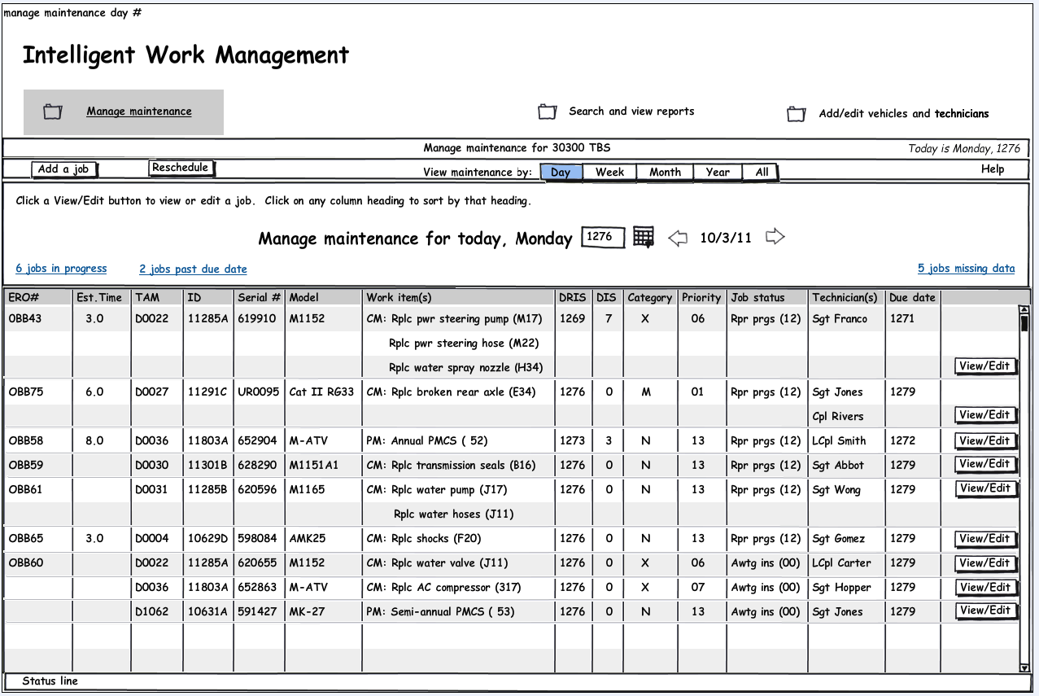

Details Tab
The Details tab includes the read-only and edit-able information available to the maintenance manager for the selected ERO. The maintenance manager has the option of editing appropriate fields. Depending on the job status, some fields will be editable and some will not. Editable fields visually look different than read only fields.

If a field is empty or editable it will have a text input box. If the field is not editable, it will appear as text with no box around it. This is true on all tabbed pages, as well as pretty much everywhere in the app.

The screen filled in with an example of the Details tab is shown on the mocked-up screen called details tab_ERO # OBB43. This may or may not be how it appears on any given job.

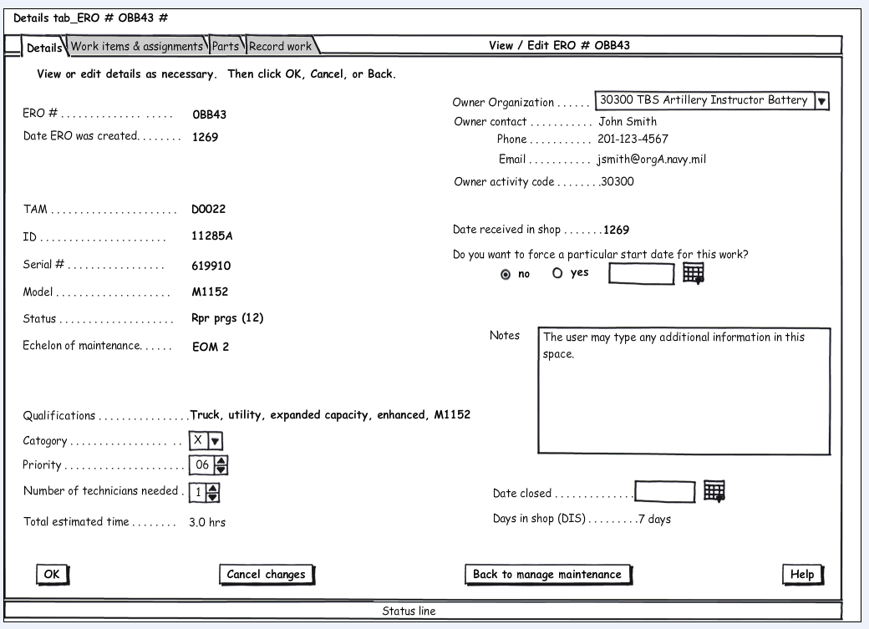

If the user hits Add a job on the initial screen, this same tabbed interface will appear with all empty text input boxes on all tabs. An example of the Details tab add a job screen is shown on the mocked-up screen called Details tab_add a job.

For the fields that have a larger number of options, as the user types the options will appear below. For instance, there are 60 TAM codes. Displaying all TAM codes in a drop down list box is not practical. However, if the user types D0 some subset of TAM code options will appear; fewer options will appear if the user types D00.

Whenever possible, the system will auto-fill information. For instance, if the user types in a serial number, the TAM, ID, and potentially other fields will be auto-filled. In addition, in future TOs, if access to appropriate databases is agreed upon, the system will auto-fill as necessary.

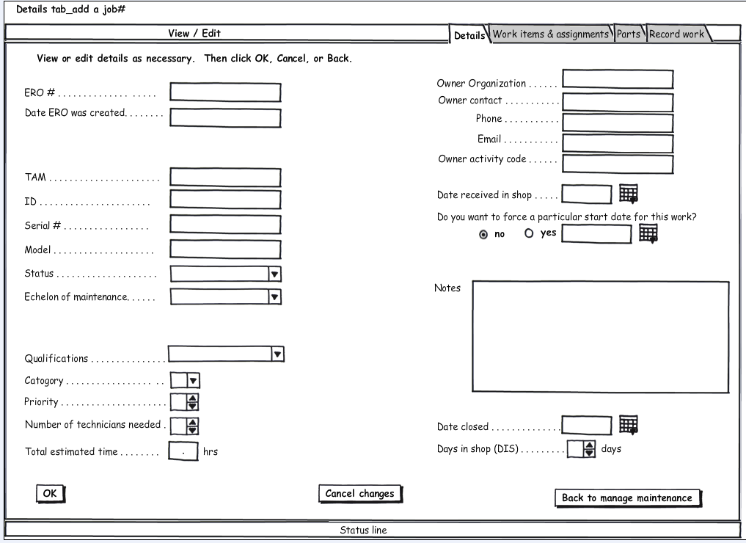

Work Items & Assignments Tab
The Work items & assignments tab includes the read-only and edit-able information available to the maintenance manager for the selected ERO. The screen filled in with an example of the Work items & assignments tab is shown on the mocked-up screen called Work items & assignments tab. The screen contains a work items table that contains 15 rows for work items that correspond to the 15 rows for maintenance items on the ERO. The work items table contains the following three columns:

Work items
Defect code
Estimated time
If the user types in the defect code into a text field in a row of the defect code column, the work item will appear in the same row of the work items column.

The Work items & assignments tab also contains a technician assignment table that lists the technicians that are qualified to work on the selected ERO and displays a checkbox that indicates the technician that has been assigned to perform the job. The maintenance manager can use the technician assignment table to manually make a change to the selected technician.

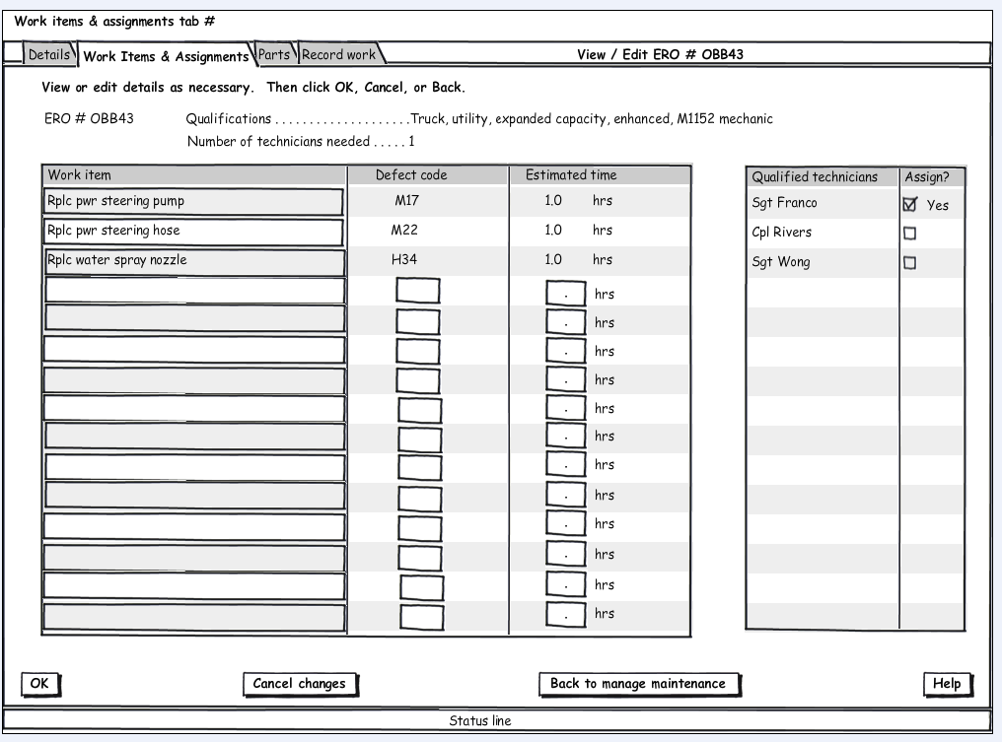

Parts Tab
The Parts tab includes the read-only information available to the maintenance manager for the selected ERO. The screen filled in with an example of the Parts tab is shown on the mocked-up screen called Parts tab. The screen contains a parts table that lists the parts required for the selected ERO. The parts table indicates if the required parts are available or out of stock and the current location of each listed part. The parts table contains the following six columns:

Work item (Defect code)
Parts needed
Stock number
Status
Anticipated receive date
Current location

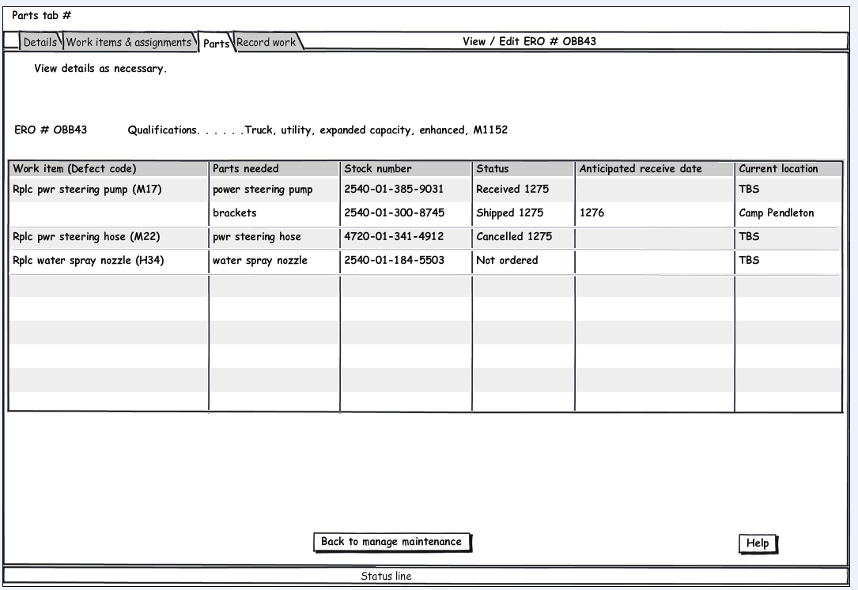

Record work tab
The Record work tab includes the read-only and edit-able information available to the maintenance manager for the selected ERO. The screen filled in with an example of the Record work tab is shown on the mocked-up screen called Record work tab.

The screen contains a work items table that lists the work items for the selected ERO and time estimated to perform each work item. It also provides fields for recording the actual time that it took to perform each work item and to record comments. The work items table contains the following five columns:

Work item
Estimated time
Technician(s)
Actual time
Technician comments

The work item, time estimates and technicians fields are not editable since it is after the work has been completed that the comments and actual time would be entered.

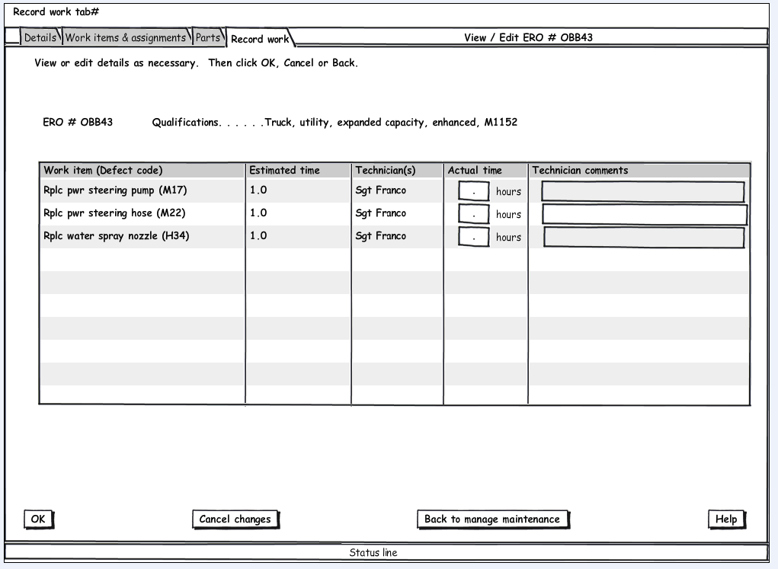

Search and View Reports Tasks
Search and view and reports tasks are performed by clicking on the Search and view reports folder, which brings the user to the Search and view reports main screen. This screen consists of tabs which allow the user to search, view search results and view several pre-defined reports.

Search tab
The search tab is shown on the mocked-up screen called Search and reports. The search tab allows the user to search for maintenance information in a flexible way, using a multi-option search design. The user chooses which criteria to search for by filling in one or more fields and clicking Add. The search box reflects the criteria input. The user may delete any of the items in the search box by selecting the item and hitting the delete button or the spacebar on their keyboard. When the user is finished with the search criteria, they will click the Search button, which jumps them to the tab that shows the results of the search. When they return to the search tab, it is blank and ready for a new search. The results tabs are grayed out until they are available.

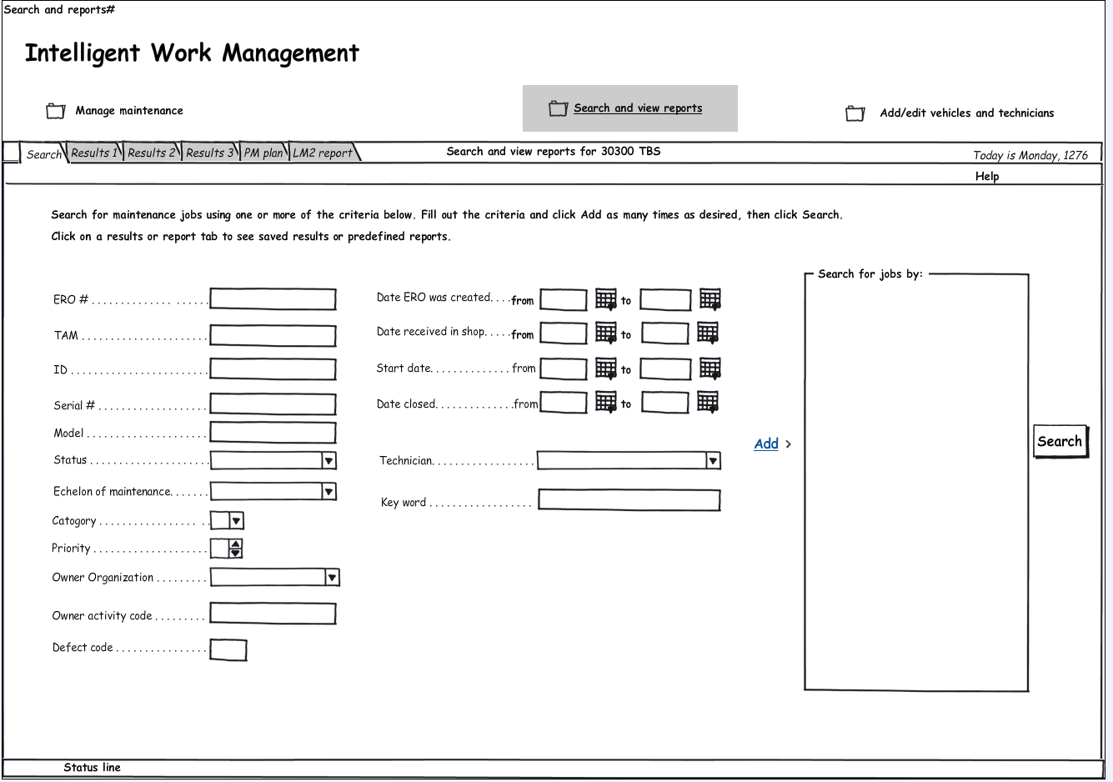

3.2 Results tabs
The Search results tabs contain the results of the search, and repeats the search criteria at the top of the screen. Search results can be saved, and searches can be run again at any time. An example of the Search results tab is shown on the mocked-up screen called Search results 1.

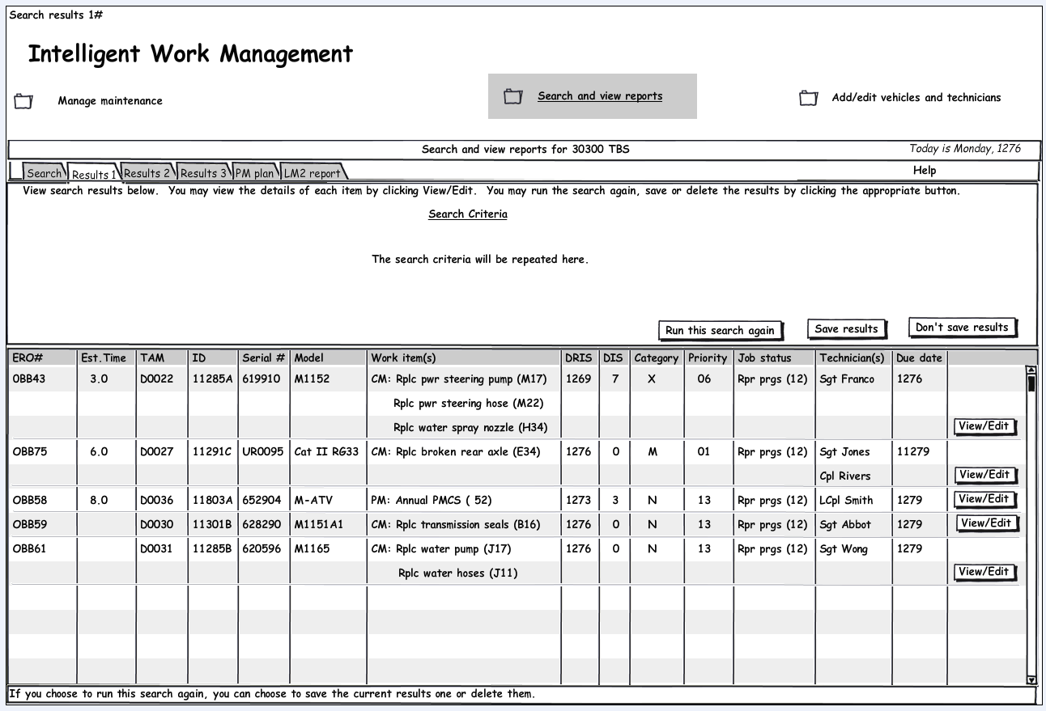

3.3 Reports tabs
There are also two tabs which contain pre-defined reports, the LM2 and the PM plan (which is also referred to as the Preventive Maintenance Checks and Services Roster 4700). These tabs contain both current and several past LM2 and PM plans.

Add/Edit Vehicles and Technicians Tasks
Add/edit vehicles and technicians tasks are performed by clicking on the Add/edit vehicles and technicians folder, which brings the user to a main screen with Technicians and Vehicles tabs.

Technicians tab

The screen defaults to the open Technicians tab. The tab displays information on all technicians that are currently loaded in the system. The user can choose to edit a particular technicians’ information, or add a new technician. The Technicians tab is shown on the mocked-up screen called Technician list.

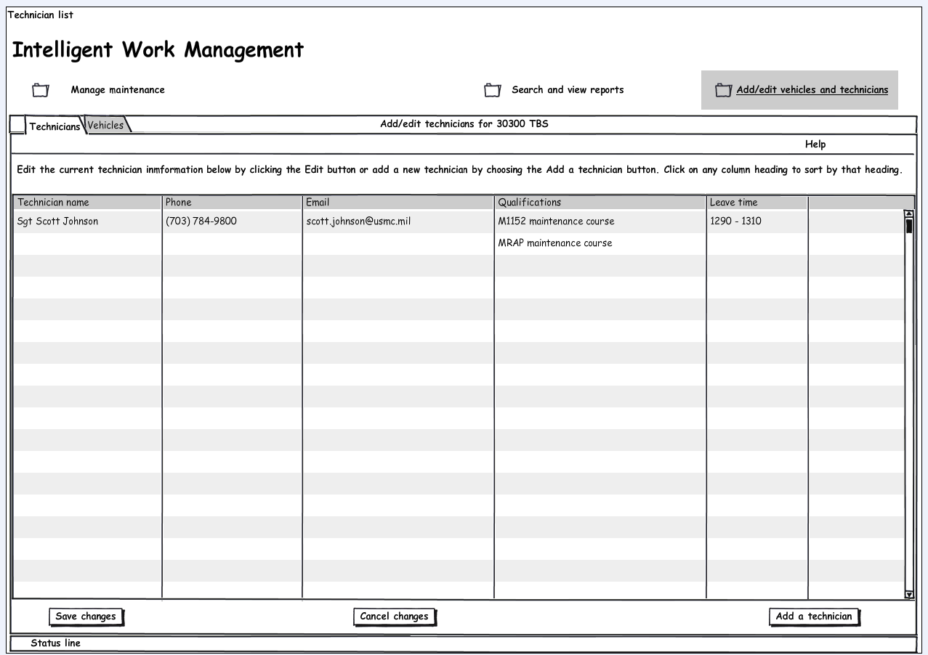

Add/edit technicians pop-up
Clicking an edit button brings the user to the Add/edit technicians pop-up, which allows the user to edit the following fields:

Technician name
Phone
Email
Qualifications
Leave time
This is also the pop-up the user would see if Add a technician was chosen. In that case the fields would be blank, allowing the user to input new information. From this pop-up the user can add another new technician, save their changes, cancel changes, clear the screen or return to the list of technicians. The Add/edit technicians pop-up is shown on the mocked-up screen called Add/edit technicians pop-up.

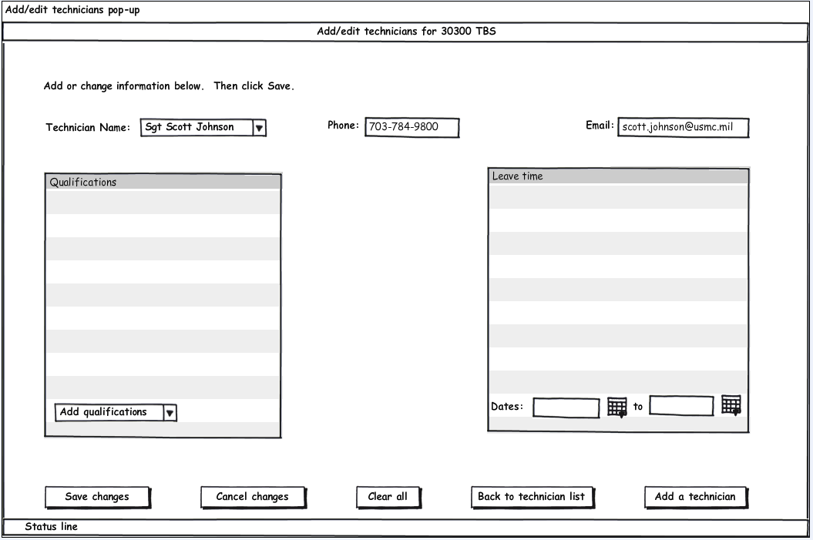

Add/edit vehicles tab

The Vehicles tab displays information on all vehicles that are loaded in the system. The user can choose to edit a vehicle’s information, or add a new vehicle. The user would edit information directly on this screen using the following fields:

TAM
Id
Serial #
Model
Owner activity code
Owner organization
Owner name
Phone
Email
Choosing Add a vehicle adds a blank row of fields for the user to enter information. The Add/edit vehicles tab is shown on the mocked-up screen called Add/edit vehicles.
